**Help Desk SQL Assignment**

We are now working with a database which notes helpdesk action.

There are two tables. First, there is the employee table, which contains the employee’s ID as the primary key, first name, last name, and location. You can assume all employees at our company are listed here.

Second, there is the ticket table, which contains each individual helpdesk ticket. The ticket table contains the ticket ID as the primary key, a description of the helpdesk incident, the duration in minutes, a priority, a status, and which employee (if any) has been assigned to the ticket. If nobody is available, a ticket will be logged into the system in this table, but no employee will be assigned yet.

The incident status can be completed, in progress, or not started. If an incident is completed, the duration field will contain the number of minutes the incident took and the employee ID will reference the employee who completed the service.

If an incident is in progress, the duration field number denotes the number of minutes since the incident started and the employee ID will reference the employee who is currently working on the service (assume for now that all incidents will be completely serviced by the single employee who is assigned to them.)

If an incident service is not yet started, the duration field will be blank, and there will not be an employee assigned to that incident, either.

Let’s get started. One difference this week in preparing the database for use in SQLiteonline.com, is that we have separated the database creation (Setup) and database population (INSERT) into two scripts, two steps. You must create the database before inserting data.

1. Print the first name, last name, ticket ID, ticket description, and duration of the employees who are assigned with a ticket(s). Sort them first alphabetically by first name (starting with letter A at the top) and then ascending by Duration.

2 -We want to get a workload by employee printout. For every employee, print the first name, last name, all ticket ID numbers assigned to that employee, the ticket description, and ticket duration of our records. Include only tickets which have been assigned to an employee. Include all employees, even if that person doesn’t have any tickets in the current database. Sort them first alphabetically by first name (starting with letter A at the top) and then ascending by ticket duration.

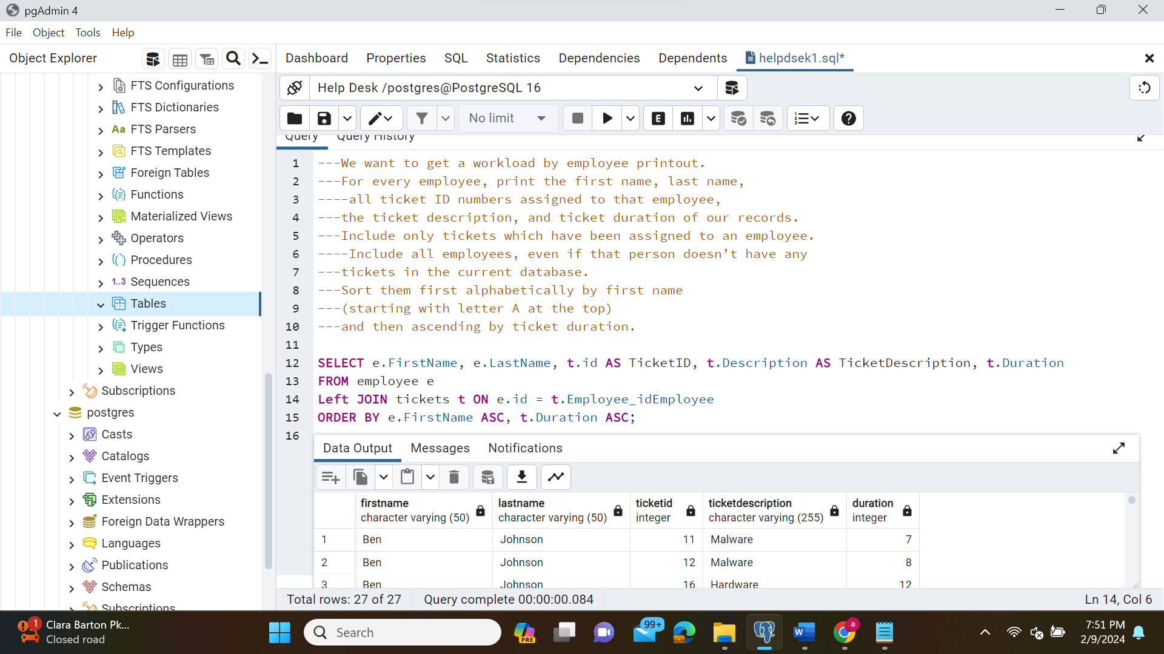

4-Management wants to pay special attention to calls which are in progress and for which the duration is currently 20 minutes or longer (include calls of exactly 20 minutes duration). Print the ticket ID number, description, duration, priority, status, and the employee first name for all of these calls.

5-You suspect there has been a malware breach at the Maryland facility. They’re not sure if it’s an inside job (involving one of your employees) or an outside job (involving an outside attack.) Make a listing of all high priority helpdesk tickets which have either been identified as malware, or which were taken by an employee whose location is in the Maryland facility. Print the description, duration, ticket ID number, ticket status, employee first name, employee location, and priority of ticket. Sort it alphabetically by description, then by duration (longest duration on top), then ascending by ticket ID number.

1. ] We want to see the total duration for completed helpdesk calls by employee. Only include employees who have completed helpdesk tickets; if an employee doesn’t have any completed tickets, their name should not show up in this report. Generate a report for which the
   * First column contains the employee’s first and last name (don’t use two columns for this – put the first and last name together)
   * Second column contains the total duration of all completed tickets by that employee. If an employee had more than one ticket, add the durations together.
   * Report is sorted so the largest total duration is on the top, and then alphabetically by employee name (sort it using the “First Last” combination, so that “Mickey Mouse” would come before “Nancy Mouse”.)
   * Only include completed tickets; don’t include those in progress or not yet started.
   * *Hint: Be sure to review the Concatenation tutorial in the LEO classroom.*

For example, assume your initial data was as follows.

|  |  |  |  |
| --- | --- | --- | --- |
| Employee First Name | Employee Last Name | Ticket status | Ticket Duration |
| Mickey | Mouse | Completed | 5 |
| Mickey | Mouse | Completed | 10 |
| Donald | Duck | In Progress | 15 |
| Donald | Duck | Completed | 20 |
| Donald | Duck | Completed | 25 |
| Donald | Duck | Completed | 30 |

Your report would contain the following information:

|  |  |
| --- | --- |
| Employee Name | Duration of completed tickets |
| Donald Duck | 75 |
| Mickey Mouse | 15 |

Note that Mickey Mouse has two calls here, both of which were completed, so their duration is 5 + 10 = 15. Donald Duck has four calls here, but only three of them are completed, so his duration is 20 + 25 + 30 = 75 minutes; Donald’s 15 minute call is still in progress and is not counted here. And Donald’s 75 minutes is the largest number of minutes, so it goes on top.

7- Do the same as Problem 6 above, except in addition to the sum of the ticket durations, also include an additional column to give us the number of completed tickets as well. Now sort your database so the largest number of completed tickets is on the top.

Here's a sample of the output for Mr. Duck and Mr. Mouse.

|  |  |  |
| --- | --- | --- |
| Employee Name | Duration of completed tickets | Total number of completed tickets |
| Donald Duck | 75 | 3 |
| Mickey Mouse | 15 | 2 |

1. 8- You want to learn more about the average duration of all tickets taken by employees in California. Include all tickets which have been completed or are in progress by employees in California. Sort them alphabetically by priority, and then alphabetically by ticket description. Additionally, group them first by priority (highest on top), then alphabetically by description. So your final report will look something like this (your data may vary):

|  |  |  |
| --- | --- | --- |
| Priority | Description | Average duration of tickets |
| 1-High | Malware | 99 |
| 1-High | Virus | 12 |
| 2-Medium | Internet | 5 |
| 2-Medium | Malware | 8 |
| 2-Medium | Virus | 3 etc. |

9- Your management wants to know what the different types of tickets are. Write a query that uniquely identifies ticket type based on the ticket description.

MMMMMM